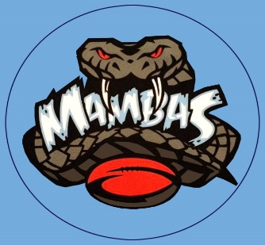
MUSWELLBROOK LADIES AND MIXED TOUCH FOOTBALL
WEEK 18 GRAND FINALS: 11th MARCH 2024

6.40pm Mixed Referee
Field 2: B GRADE DIV 1: VSR STALLIONS vs VALLEY FASTENERS
Leon Doyle

Field 3: A RES DIV 2: KUZZIEZ WHITE vs PERFS Mitchell Galvin

Field 4: A GRADE DIV 1: WE STAY YOU GO WILDCATS vs FLYING FLIPPERS
Liam Anderson/Daniel Chapman

7.15pm Mixed Referee
Field 2: B GRADE DIV 2: JMG MAINTENANCE vs BC CIVIL WORKX
Leon Doyle

Field 3: A RES DIV 1: WARRIORS vs OBRIENS RECYCLING
Scott Fulloon

Field 4: A GRADE DIV 2: MUD CRABS vs HAPPY TOOTH DIVAS
Liam Anderson/Daniel Chapman

