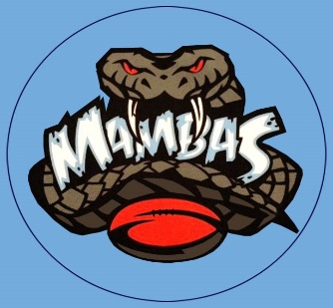
MUSWELLBROOK LADIES AND MIXED TOUCH FOOTBALL
WEEK 5: 14th FEBRUARY 2022

6.30pm Mixed Referee
Field 1: Aberdeen vs CU at the Bar Kane Cubillo
Field 2: Say Cheese vs Warriors Leon Doyle
Field 3: Swamp Donkeys vs PIRTEK Tyreece Anderson
Field 4: Bradys Team vs Mud Crabs Liam Anderson
Field 5: Call Me Speed vs Can’t Touch This Liam Galvin
Field 6: Kuzziez BROZ vs Cobras Daniel Chapman

7.10pm Mixed Referee
Field 1: Kuzziez Gold vs Touchy Feely Leon Doyle
Field 2: Betta Electrical vs CHAOS Mitch Galvin
Field 3: Drews Tipper Hire vs BOBCATS Jacob Ellis
Field 4: Kuzziez vs Dream Team Hayden Fox
Field 5: WDS vs Kuzziez BRS Painting Daniel Chapman

