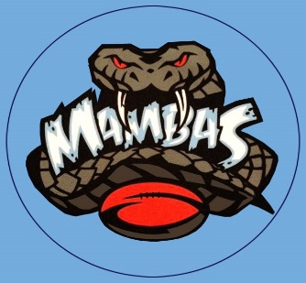
MUSWELLBROOK LADIES AND MIXED TOUCH FOOTBALL
WEEK 1: 19th OCTOBER 2020

6.00pm Ladies Referee
Field 3: North Stars vs Lady Cats Tyreece/Liam Anderson
Field 4: U16 Rep Mambas vs Kuzzie Girls Liam Galvin

6.45pm Mixed Referee
Field 1: Not Fast But Furious vs Aberdeen Leon Doyle
Field 2: PPS vs Michael Johnson Tyreece Anderson
Field 3: Mud Crabs vs Can’t Touch This Jacob Ellis
Field 4: BLOAT FC vs White Line Fever Liam Anderson
Field 5: Snatch N Grab vs Hunter Valley Concrete Mitch Galvin
Field 6: Blu Water vs Chiropractic Life M’Brook Lachie Clare

7.30pm Mixed Referee
Field 1: Betta Electrical vs Easier Said Than Run Mick Mellick
Field 2: Touch Feely vs WAP Leon Doyle
Field 3: WARU vs Class On Grass Bomber Jones
Field 4: PIRTEK vs Bob Cats Liam Galvin
Field 5: The Kuzziez vs Swamp Donkeys Anthony Cubillo
Field 6: Your Shout vs CU at the Bar Mitch Galvin

